**1- Introduction**

Every Academic institution work to offer the best environment and services for its students and employees. This project aims to provide a system that allows the user to create requests in Umm Al Qura, to provide the best environment for the students and staff, to improve the service’s quality, and to make sure that the employees give their best performance. This system is designed to provide specific features, which are:

1- Provide the ability to create requests and complains.

2-Provide the ability to create service performance review.

3-Provide the request’s creator the ability to chat with the request’s recipient for documentation.

4-Provide the ability to track the request.

5-Provide the request’s recipient the ability to respond, edit, and forward the request.

**-The problem AND Solution:**

The requests are delayed from the employees and there is difference in Level of services provided by the departments and the professors. The solution is a system that optimizes all services that the students and the staffs need, and important to have a system that offer a higher level for service provided by the departments and the professors.

**2-Main Idea**

In Saudi Arabia people have trouble with their documents in the Academic institutions, This project uses an workflow optimization to create a system that improves the work environment in Saudi Arabia. And implementing it in Umm Al Qura University will help give the best services to the students and the Staffs.

**3-Intended Outcome**

workflow optimization to create a system that improves the work environment for submission of requests and respond to them,Provide the ability to a key performance indicator(KPI).

**4-Materials and Methods**

System to offer the best environment and services for students and employees, Through the following image we will show the method the workflow.

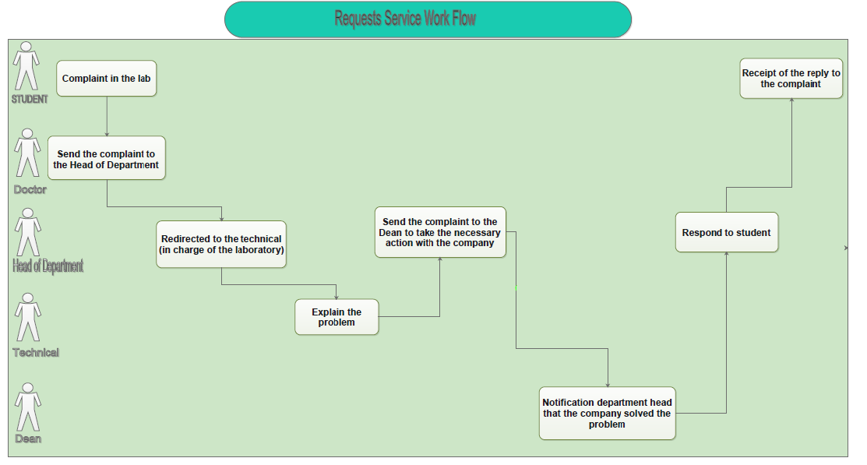

The System is on Web browser and we will use:

• php , java script , css , html

• Apache web server 2.2 + PHP5

• Database: PHP MYADMIN MySQL

• Internet for communication between users

**5-Stage**

سوف نضع الواجهات للموقع

**6-Results**

This system is improves the performance level, and provide (predestined ) courses.

**7-Conclusion**

we want the best solution for students doctors, managers and departments and help them workflow optimization to create system that improves the work environment in Saudi Arabia, and to be implemented in Umm AlQura University

through:

Improve the quality of the service. 1-

2-Provide the ability to create a key performance indicator(KPI).

3-Achieve the service-level agreement (SLA).

finally we wish that all users who can use the system to be happy.

**future research-**

1. We wish that we can cover all universities in Saudi Arabia.
2. Link our project with the university’s DB.